UNIT 1 Ecotourism
1．Text
The ideas behind ecotourism are not new. Rooted in the conservation and environmental movements in the United States over the past 150 years – spurred by the writings of Thoreau, Muir, and before them, Buddhist and other philosophical ideologies – ecotourism is a new application for an age-old concept of stewardship. It recognizes the interconnections of all life and the importance of maintaining a balance between human needs and those of existing ecosystems.
Perhaps Aldo Leopold’s famous Land Ethic best captures the philosophical essence of stewardship: “a thing is right when it tends to preserve the integrity, stability and beauty of the biotic community… it is wrong if it does otherwise.” In diversity there is stability. Ecotourism is really nothing more than the application of this philosophy to the self-enriching discovery made possible through travel. It is a process and an ethic, not an end in itself.
Ecotourism has demonstrated growth far in excess of the so-called “mass tourism” market by posting (displaying) 30% annual increases between 1995 and 2000. This increase can be compared to the 8% growth in mass tourism over the same period.
According to the Travel Industry Association of America, over 50% of the U. S. adult travelling public – 147 million people -- have taken an “adventure” trip in their lifetime. Included on this “adventure” activity roster are camping, hiking and biking. Though a small portion of the overall tourism industry, ecotourism’s profit margin tends to exceed that of mass tourism. Last year, the average ecotourism two-week package cost is $3,500.
Ecotourism has both the potential to change the way we view travel and to provide the means to care for our diverse and rich resources. Western society (about 1.2 billion people) cannot bring the remaining 5.1 billion people in less developed countries up to the Western consumptive “standard of living” without exhausting the earth’s resources. Ecotourism creates a situation where both the West and the less developed societies can converge toward the middle. Ecotourism is the “common ground” because it fundamentally changes the economic dynamics of business. Ecotourism recognizes the ecological and cultural costs of doing business as well as champions “local economy”, i. e., the community becomes strong and cohesive by what’s developed and sustainably managed on a local level.
As a part of the service industry, ecotourism promotes what Alan During, in his important book How Much is Enough calls the “shift from material to non-material ends”. This shift is the only viable way in which human demands made on the environment will not overrun the carrying capacity of the planet. Ecotourism is in fundamental opposition to consumption as a means to fulfillment; rather, the sense of place, the excitement of experience, and the opportunity of learning become the overriding products “sold” to ecotourists. These ecotourism “products” are based upon preserving and protecting the original cultures and environments, not upon transforming them into some Disneyland-like fantasy-world.
Increasingly, a conservation ethic and a viable process of development have emerged from the ecotourism movement, or perhaps vice versa. The ecotourism ethic has been defined by the Ecotourism Society to mean: “responsible travel that conserves the natural environs and sustains the well-being of local people. Ecotourism offers travelers the means to assist personally and locally in the conservation of threatened environments and to support communities directly that are seeking viable economic alternatives to cycles of poverty and environmental destruction.” This non-profit organization is working to raise public support for implementing ecotourism principles and practices around the world.
The concerted effort by policy makers, businesses, recreation managers and organizations such as the World Wildlife Fund and Conservation International to define and make ecotourism a mainstream practice is promising. We in the Western industrialized nations have an incredible opportunity for restorative and regenerative change through ecotourism. There seems to be little doubt that tourism will continue to grow; the most important question remains: Will it be ecologically responsible and sustainable?
The responsibility clearly rests with ourselves to care for an environmental and cultural diversity which historically we have used merely to serve our needs – and our needs only.
Ecotourism, as a model, process and ethic, offers an opportunity to put respect for our earth into practice in a way that all people can enjoy its beauty and benefits.
- New words and expressions:
conservation: 守恒；保护
spur: 鞭策；刺激；激励
Buddhist: 佛教的
stewardship: 管理
preserve: 保留；保护
integrity: 完整（性）
diversity: 多样性
adventure trip: 探险之旅
roster: 候选名单
mass tourism: 大众旅游
consumptive: 消费的
common ground: 共识；共同利益
dynamics: 动力学；动态；动力
champion: 支持；捍卫；声援
cohesive: 凝聚力
service industry: 服务业
carrying capacity: 承载能力
overriding: 最重要的；凌驾一切的
fantasy-world： 梦幻世界
ethic: 伦理
viable: 切实可行的；可实施的
alternative: 替代方案
non-profit organization: （NGO）非盈利组织
implement: 贯彻；执行
restorative: 恢复性；恢复健康的；滋补的
regenerative: 再生的；再造的
sustainable: 可持续的
- Notes:
Thoreau: Henry David Thoreau (1817-1862) was an American essayist, philosopher, and poet. Thoreau’s writing is heavily influenced by his own life, in particular his time living at Walden Pond. He has a lasting and celebrated reputation for embracing non-conformity, the virtues of a life lived for leisure and contemplation, and the dignity of the individual. （An Introduction of Thoreau:视频链接）https://haokan.baidu.com/v?pd=wisenatural&vid=8861357920064531814
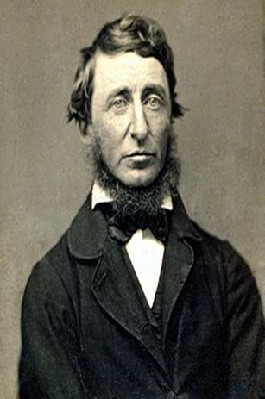
Muir: John Muir (1838-1914) was an explorer, mountaineer, conservationist, botanist, amateur geologist and writer of distinction. He developed a passion for wild places growing up in the coastal town of Dunbar, east of Edinburgh. At age 10, he emigrated to the United States with his family. Muir embraced all nature from mosquitoes to mountain ranges, recognizing that everything is connected. His passion for wild places led to a life-long quest to protect them. Muir’s writings helped people understand the importance of wildness. His activism saved Yosemite Valley in California and helped create the world’s first national park system. （An Introduction of John Muir视频链接: https://m.bilibili.com/video/BV1XV411q79Q?p=6）
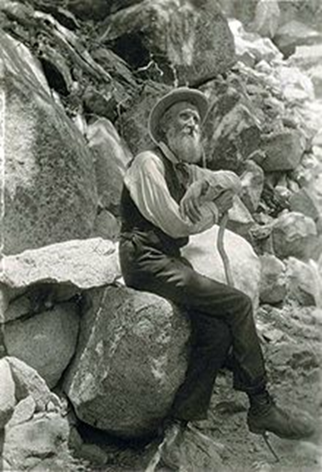
Aldo Leopold: Considered by many to be the father of wildlife ecology and the United States’ wilderness system, Aldo Leopold was a conservationist, forester, philosopher, educator, writer, and outdoor enthusiast. Among his best known ideas is the “land ethic,” which calls for an ethical, caring relationship between people and nature.（Leopold’s ecological restoration experiment（生态修复实验）on a worn-out farm along the Wisconsin River outside of Baraboo, WI. During weekends at “the Shack,” the family planted thousands of pine trees and restored prairies.视频链接 http://www.bilibili.com/video/BV1Bs411h7Bp?p=41）
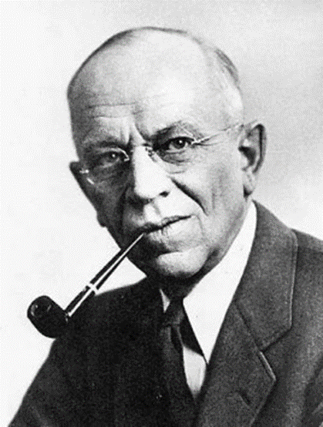
Alan During: 艾伦·杜宁，美国纽约世界观察研究所资深研究员，获得奥柏林学院哲学和环境政策硕士学位。著有多篇论文，涉及贫困、种族隔离、土著人、森林和动物农场的环境后果。
How Much is Enough: How much is enough——The Consumer Society and the Future Of the Earth: Alan Durning. W.W. Norton & Company, New York, 1992. 《多少算够》荣获纽约哈里肖邦媒体奖。消费主义生活方式蔓延全球,仅仅一代人的时间,人类中绝大多数已经成为汽车驾驶员/电视观众和受广告支配的消费者。然而，消费主义让我们成为物欲的奴隶，却不能给我们以充实和富足感，因为我们仍然是社会、心理和精神上的饥饿者。如果人类拥有太多，地球将受难，问题是多少算够？怎样的消费是这个行星可以承受的？如果不调整我们消费主义的生活方式，将毁灭我们的地球。
Conservation International: 保护国际 (简称 CI)成立于1987年，是一个总部在美国华盛顿特区的国际性非营利环保组织。宗旨是保护地球上尚存的自然遗产和全球的生物多样性，并以此证明人类社会和自然可以和谐相处。保护国际通过科学技术、经济、政策影响和社区参与等多种方法，保护热点地区的生物多样性。 保护国际在全球四个大洲超过30个国家开展工作。
- Translation Exercise: （注意定语从句的翻译）
- Ecotourism creates a situation where both the West and the less developed societies can converge toward the middle.
生态旅游业使西方世界和一些欠发展国家得以汇合。
- This shift is the only viable way in which human demands made on the environment will not overrun the carrying capacity of the planet.
为了让人类对环境的需求不会超过地球的最大承载能力，这种变化是唯一可行的办法
3）The ecotourism ethic has been defined by the Ecotourism Society to mean: “responsible travel that conserves the natural environs and sustains the well-being of local people.
生态旅游学的伦理被生态旅游协会定义为：保护自然环境和维持当地居民生存的负责任的旅游。
4）Ecotourism offers travelers the means to assist personally and locally in the
conservation of threatened environments and to support communities directly that are seeking viable economic alternatives to cycles of poverty and environmental destruction.”
生态旅游给旅行者提供个人与当地在保护受到威胁的环境以及直接支持寻求可行的经济代替方案以打破贫穷与环境破坏循环的社会的帮助的方式。
5）The responsibility clearly rests with ourselves to care for an environmental and cultural diversity which historically we have used merely to serve our needs – and our needs only.
这种责任心明显让我们去关心环境与文化的多样性，与之相比，在历史上我们仅仅只用来满足自己的需求——而且只有我们自己的需求。
6） Ecotourism, as a model, process and ethic, offers an opportunity to put respect for our earth into practice in a way that all people can enjoy its beauty and benefits.
生态旅游业，作为一个模型，过程以及伦理，提供了一种让所有人可以享受地球的美丽与利益的方法来在实践中尊重地球。
7） China’s period of strategic opportunities is nothing but an international environment and evolutionary process where world peace is maintained and common development promoted.
中国的战略机遇期正是维护国际和平，促进共同发展的国际环境和演变过程。
8） The other phenomenon is globalization, which has unleashed economic, political, and social forces that are beyond the capacity of any one country, including the United States, to control.
另一个现象就是全球化，它释放出来的经济、政治和社会的力量不是任何一个国家可以控制的，包括美国在内。
9） On behalf of all of our American guests, I wish to thank you for the incomparable hospitality for which the Chinese people are justly famous throughout the world.
我代表我们所有美国的宾客，想对你们无与伦比的热情表达感谢，让中国人民在世界上著称。
10）The United States was also one of the very few countries that refused to sign the biodiversity treaty.
美国也是极少数拒绝在生物多样性合约上签字的国家之一。

